|  |  |
| --- | --- |
| C:\Users\Plasma-PC\Desktop\logo.jpg | **MINISTRY OF EDUCATION AND TRAINING** |

**FPT UNIVERSITY**

**Capstone Project Document**

**Olives**

Project Code: Olives  
Document Code: **Olives_PP_v1.0**

|  |  |  |
| --- | --- | --- |
| **Olives Team** | | |
| **Group member** | Phạm Đức Thắng | SE03055 |
| Trần Ánh Dương | SE02797 |
| Phạm Minh Tuấn | SE02875 |
| Bùi Quốc Trọng | SE03418 |
| Nguyễn Văn Hưng | SE02582 |
| Nguyễn Duy Linh | SE03150 |
| **Supervisor** | Lecturer: Phan Trường Lâm | |
| **Capstone Project code** | Olives | |

**Hoa Lac, 18th May 2016**

**CONTENT**

**1.** **Problem Definition** 2

1.1 Name of this Capstone Project 3

1.2 Problem Abstract 3

1.3 Project Overview 3

1.3.1 The Current System 3

1.3.2 The Proposed System 3

1.3.3 Boundaries of the System 3

1.3.4 Development Environment 3

**2.** **Project organization** 4

2.1 Software Process Model 4

2.2 Roles and Responsibilities 5

**3.** **Project Management Plan** 6

**3.1** **Task** 6

**3.2** **Project Schedule** 6

**3.3** **Meeting Minutes** 6

**4.** **Resource** 6

**5.** **Risk Management** 6

**6.** **Communication Management** 6

**9.** **Project Infrastructure** 8

9.1 Software and Techniques 8

9.2 Hardware 9

9.3 Other Infrastructure 9

**10.** **Coding convention** 9

**11.** **Version Numbering Rule** 9

**12.** **Directory Structure** 10

**13.** **Other Olives Rules** 11

# Screen Flow

## Sign In Your Account Screen

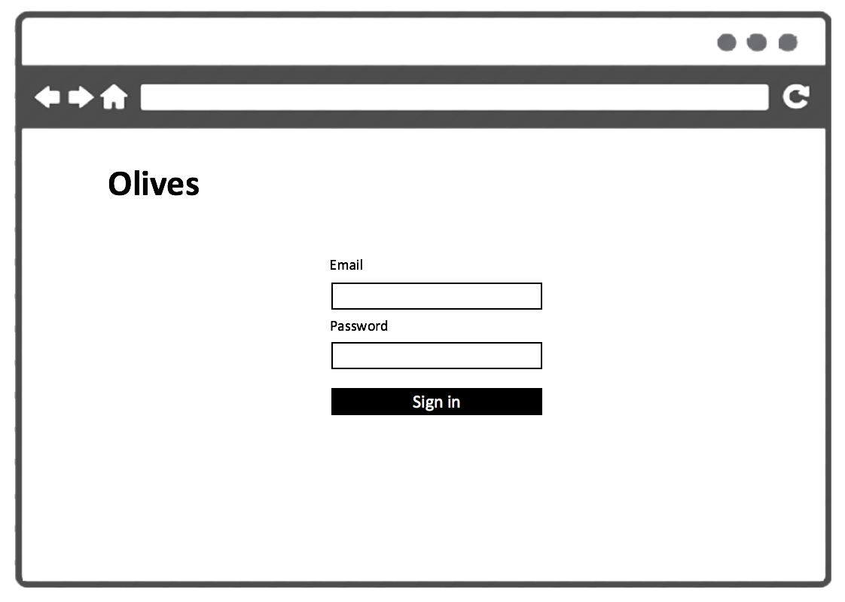

|  |  |  |
| --- | --- | --- |
| Element | Type | Description |
| Sign In | Button | Click to sign in |
| Email | Input Text | Text filed for entering name of user |
| Password | Input Text | Text firld for entering password of user |

## Request Adminstration Screen

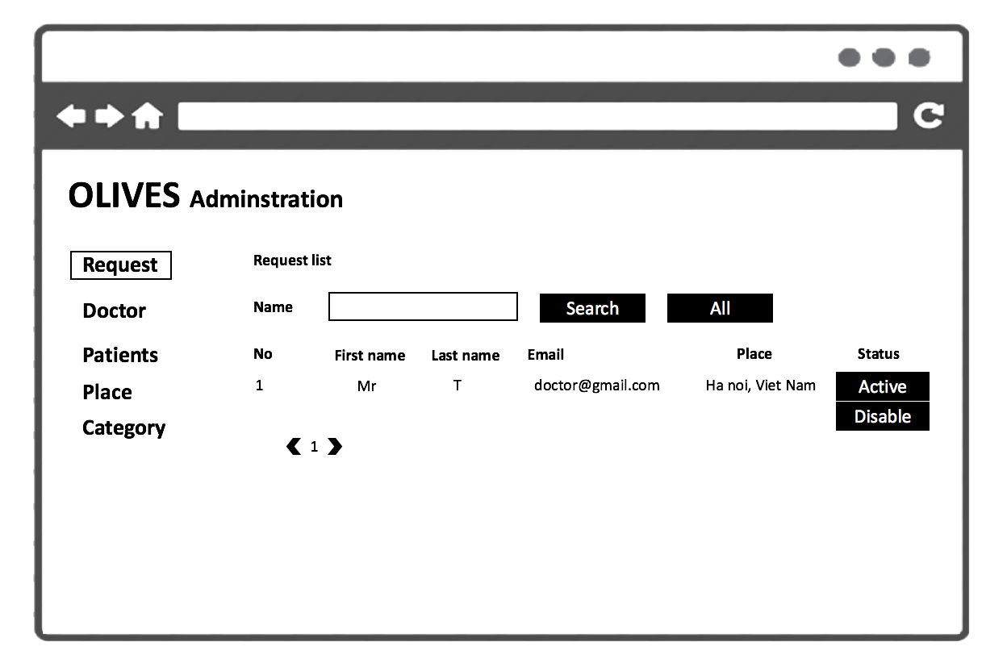

|  |  |  |
| --- | --- | --- |
| Element | Type | Description |
| Request list | Scroll View | Scroll down to view more request. |
| Disable | Button | Click to disable account |
| Name | Input Text | Text filed search name of user |
| Active | Button | Click to active acount |
| Search | Button | Click to search account for name |
| All | Button | Click ti show all account |

## Doctor Adminstration Screen

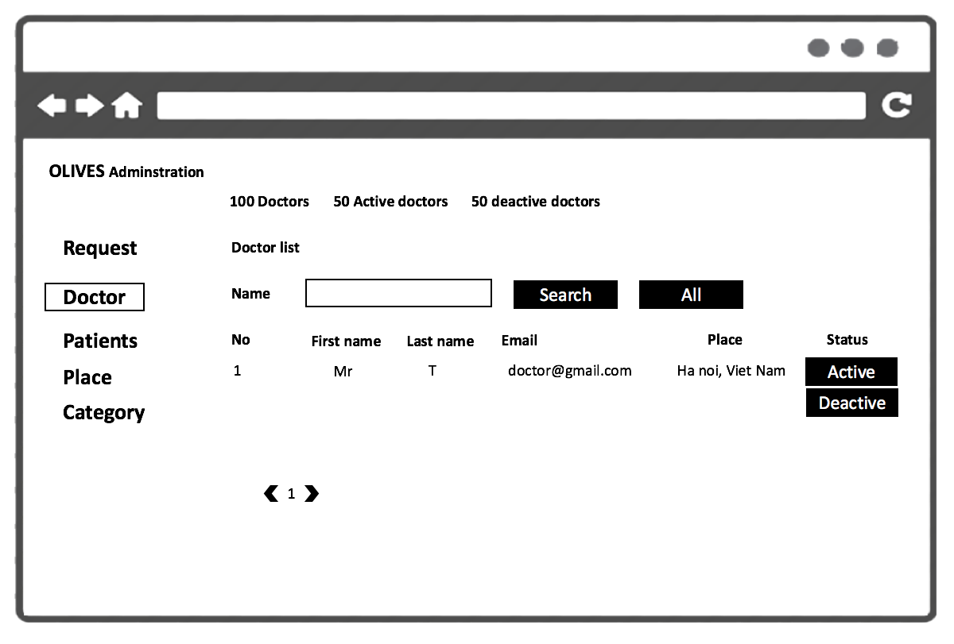

|  |  |  |
| --- | --- | --- |
| Element | Type | Description |
| Doctor list | Scroll View | Scroll down to view more doctor. |
| Disable | Button | Click to disable account of doctor |
| Name | Input Text | Text filed search name of doctor |
| Active | Button | Click to active acount of doctor |
| Search | Button | Click to search account doctor for name |
| All | Button | Click ti show all account of doctor |

## Patients Adminstration Screen

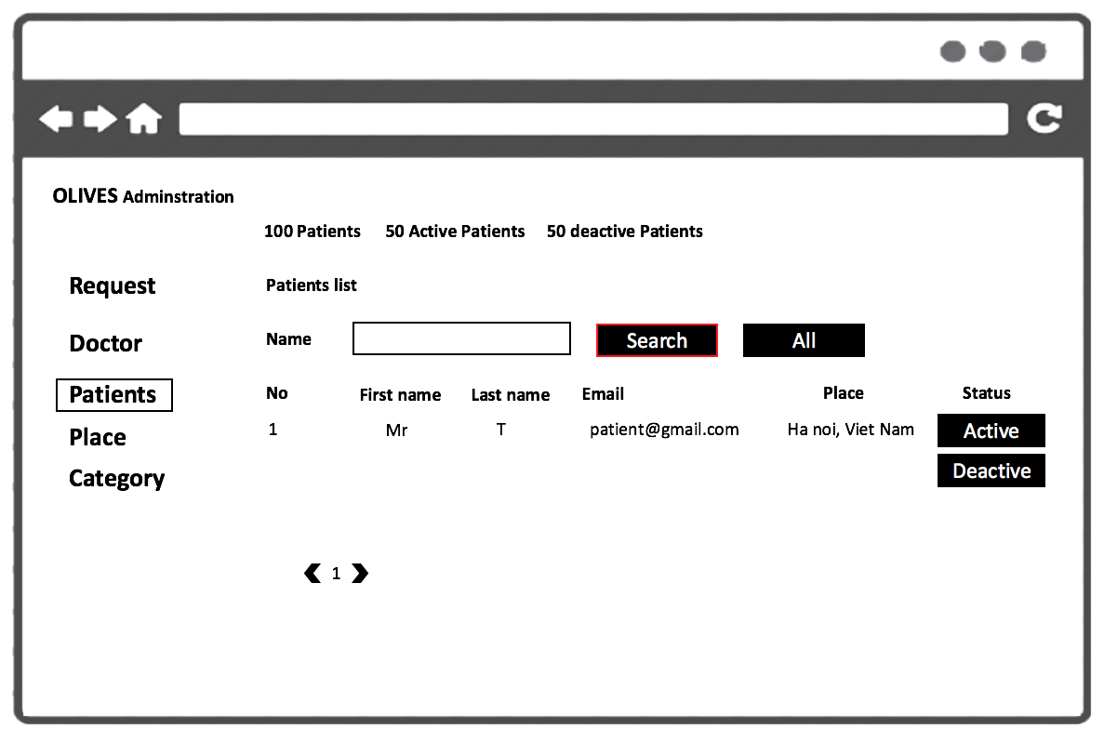

|  |  |  |
| --- | --- | --- |
| Element | Type | Description |
| Patients list | Scroll View | Scroll down to view more patients. |
| Disable | Button | Click to disable account of patient |
| Name | Input Text | Text filed search name of patient |
| Active | Button | Click to active acount of patient |
| Search | Button | Click to search account patient for name |
| All | Button | Click ti show all account of patient |

## Place Adminstration Screen

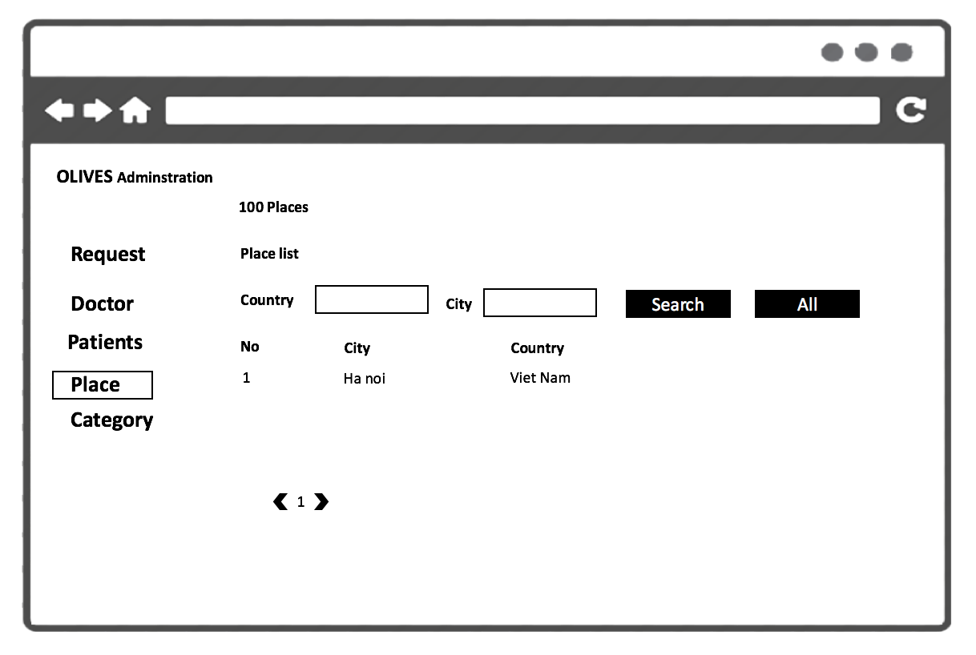

|  |  |  |
| --- | --- | --- |
| Element | Type | Description |
| Place list | Scroll View | Scroll down to view more place. |
| Country | Input Text | Text filed search country |
| City | Input Text | Text filed search city |
| Search | Button | Click to search account patient for name |
| All | Button | Click ti show all account of patient |

## Category Adminstration Screen

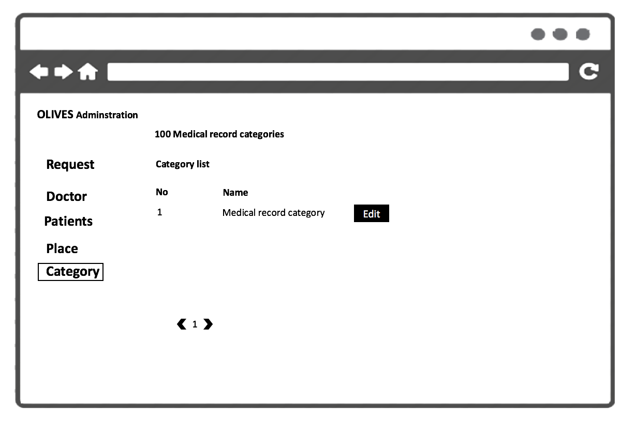

|  |  |  |
| --- | --- | --- |
| Element | Type | Description |
| Category list | Scroll View | Scroll down to view more category of medical record. |
| Edit | Button | Click to edit category |

## Edit Category Screen

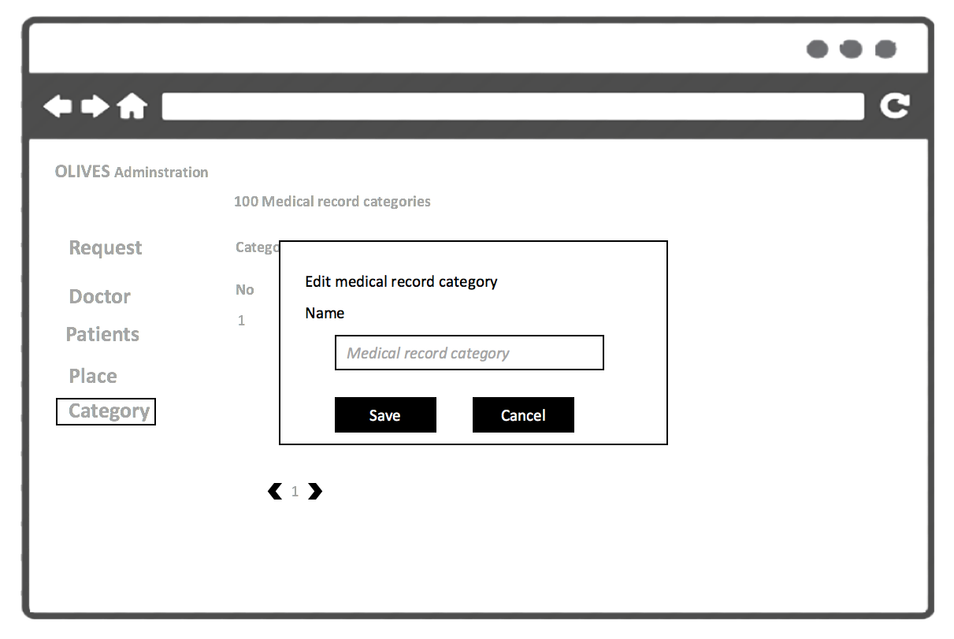

|  |  |  |
| --- | --- | --- |
| Element | Type | Description |
| Name | Input Text | Text Field for entering name of category . |
| Save | Button | Click to save category |
| Cancel | Button | Click to cancel |

## Add Category Screen

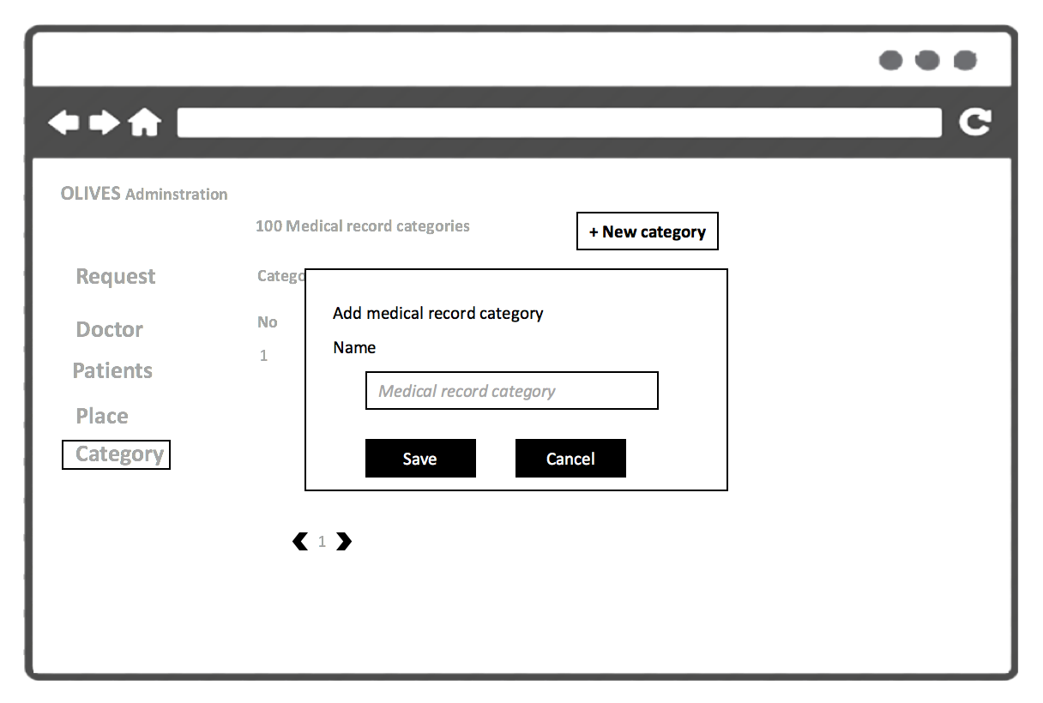

|  |  |  |
| --- | --- | --- |
| Element | Type | Description |
| Name | Input Text | Text Field for entering name of category . |
| Save | Button | Click to save category |
| Cancel | Button | Click to cancel |

## Add Place Screen

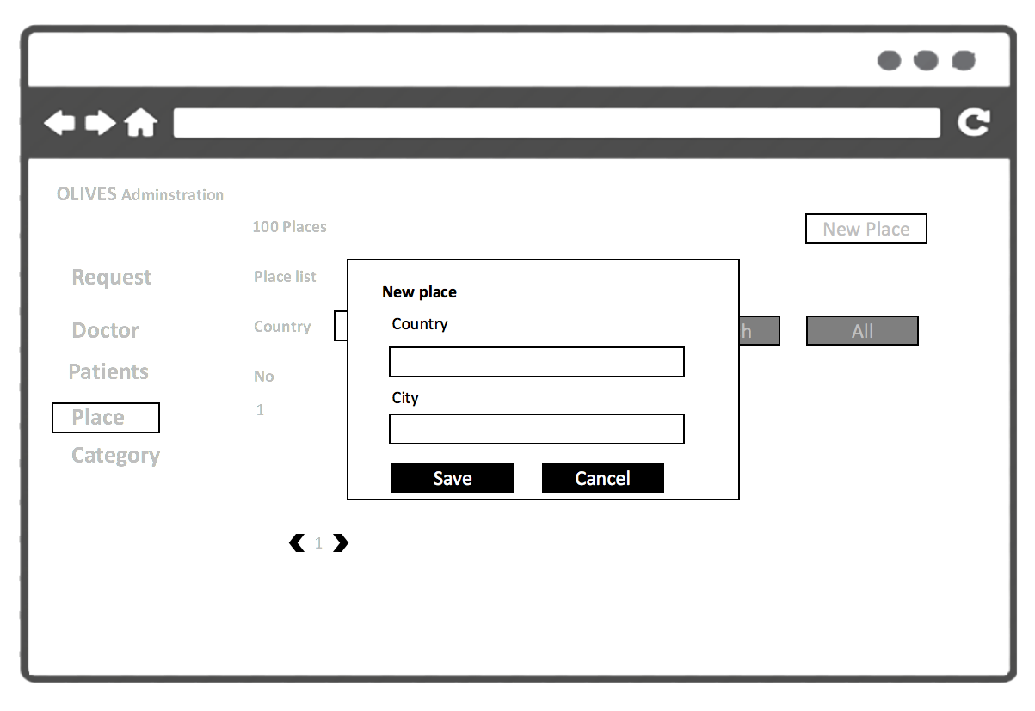

|  |  |  |
| --- | --- | --- |
| Element | Type | Description |
| Country | Input Text | Text Field for entering name of country . |
| City | Input Text | Text Field for entering name of city . |
| Save | Button | Click to save palce |
| Cancel | Button | Click to cancel |

## Edit Place Screen

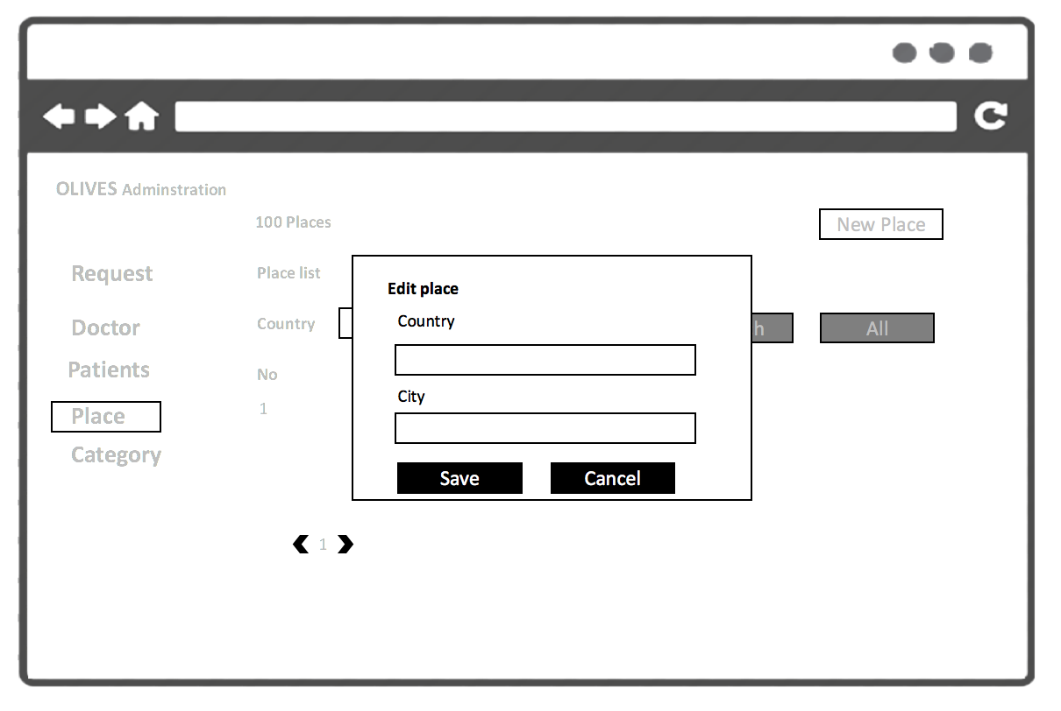

|  |  |  |
| --- | --- | --- |
| Element | Type | Description |
| Country | Input Text | Text Field for edit name of country . |
| City | Input Text | Text Field for edit name of city . |
| Save | Button | Click to save palce |
| Cancel | Button | Click to cancel |